**INTI International College Penang School of Engineering and Technology**

**3+0 Bachelor of Science (Hons) in Computer Science, in collaboration with Coventry University, UK**

**3+0 Bachelor of Science (Hons) in Computing, in collaboration with Coventry University, UK**

**Coursework cover sheet**



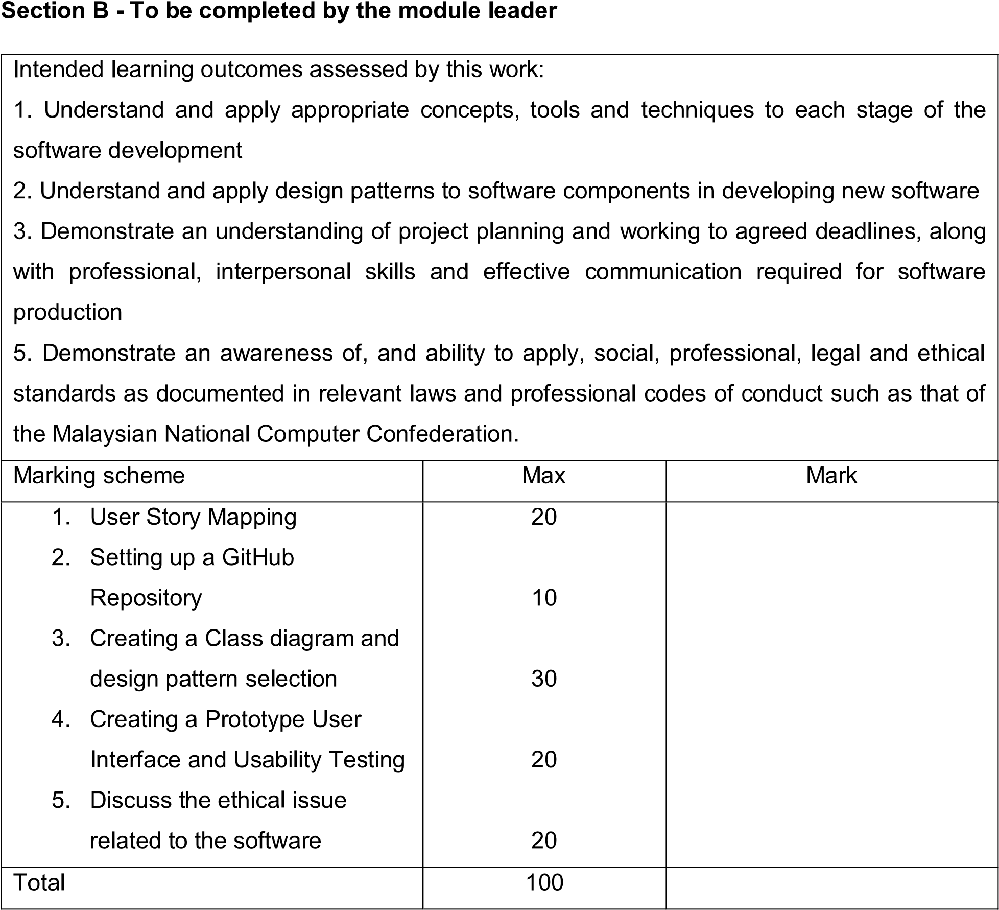

**Task 5 – Ethical issue related to the software**

**5.1 Laws of computer and technology**

**5.1.1 Copyright Law**

The legal authority of the owner of an intellectual property is referred to as copyright. The license to copy is the simplest definition of copyright. The only people who have the legal right to procreate a work are the founding inventors of that work and anyone to whom they grant permission. For a specific period after which the copyrighted object enters the public domain, copyright law grants original source material producers the sole right to continue using and duplicating their work.

A work is recognized original under copyright law if it was produced by the creator independently and without the use of any existing work. An Original Work of Authorship is the term for this kind of work (OWA). Anyone who has an original work of authorship immediately owns the copyright to that work, barring others from exploiting or copying it. The original owner of the copyright has the option to voluntarily register it if they want to have a stronger position in the legal system.

The copyright law is incorporate the Buddy System. The Buddy system is belonging to software category; hence software developers of this Buddy System are the common users of software copyright to stop software from being copied without permission. The Buddy System comprises sets of instructions that can direct a system to carry out a certain task or produce a specific outcome which is unique from the others. These instructions may be written in words, codes, schemes, or other ways. This Buddy System's terms, codes, schemes, and other forms could be protected under copyright laws as creative works, just like a book, a movie, or a piece of art.

**5.1.2 Terms and Conditions**

Owners of a particular system can inform users of the terms, rules, and regulations controlling usage of the website or mobile app by including them in a Terms and Conditions agreement. Areas including permissible use, prohibited actions, and responsibility restrictions are covered. A Terms and Conditions agreement serves as a binding contract between the user and the corporation. The terms of service are provided here, along with other crucial information and precautions, and owners can retain the right to ban users from the app if they misuse the website or app.

An agreement with Terms & Conditions is entirely optional. The owner of the application is not required by law to have one. Besides, the owner of a website or an application could freely establish the Terms and Conditions agreement. While some terms are common and standard in almost every Terms and Conditions agreement, it is up to the owner to establish the requirements that the user must accept.

Owner of the Buddy System has the right to exclude abusive users or those who don't adhere to the regulations and instructions if the system's terms and conditions are present. Since this Buddy System allows user to upload multimedia files such as pictures or videos, the terms and conditions restrict the user to upload inappropriate content as this application is utilized by mostly students. Moreover, The Terms and Conditions agreement outlines your ability to delete the accounts of users who violate them, which aids you in preventing abuses. Users that engage in abusive behaviors, such as spamming other users, attacking people in the comment section, or attempting to introduce viruses into the Buddy system, will have their accounts cancelled.

**5.2 Computer Ethics**

When Computer programmers who think a project's timetable is unattainable might hesitate to tell their boss or client about it in the absence of a code of ethics. According to the Code, computer programmers should gather proof and record their concerns if they believe a project is likely to fail. According to the Code, they have a professional obligation to immediately inform their colleague or client of their concerns.

It can take a lot of time to remain updated in computer programming, and many computer programmers don't even attempt. Although it might not seem to be an ethical issue, there is clearly a problem with professional conduct. Without staying up to date on profession-related knowledge, one cannot perform at a professional level. A person who doesn't wish to continue their own education can still work in the software industry to some extent, although the Code of Ethics and Professional Practice states that a professional software engineer must actively pursue lifelong learning.

References :

1. <https://www.investopedia.com/terms/c/copyright.asp>
2. <https://www.termsfeed.com/blog/sample-terms-and-conditions-template/#What_Are_Terms_And_Conditions_Agreements>